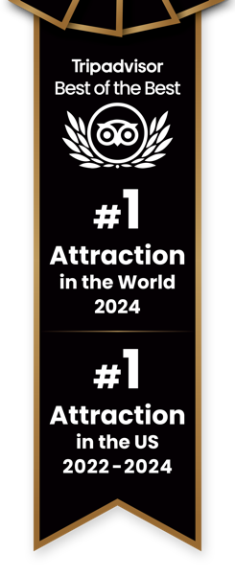

|  |  |
| --- | --- |
| **BRANDING & ATTRACTION INFORMATION**  **Hours of Operation:**  **Please see** [**FAQs**](https://www.esbnyc.com/FAQ) **on website for updated hours**  **PLEASE SEE ALL ASSETS** [**HERE**](https://www.dropbox.com/scl/fo/pohg13pxsem3kkj0fpm5v/h?dl=0&rlkey=ihd3e8z0093dscw1owmwlkyfv) **AND ON THE LAST PAGE** |  |

|  |  |  |  |  |  |  |  |  |
| --- | --- | --- | --- | --- | --- | --- | --- | --- |
| |  |  |  | | --- | --- | --- | | **All Available ESB Products for Reference:** | | | | **Main Deck/Standard**  **Tickets** | **Starbucks Reserve Sunrise Experience** | **Express Tickets** | | | |
| **PRESS QUOTES**   |  |  |  | | --- | --- | --- | | New York Times (NYT) Logo and symbol, meaning, history, PNG, brand  *“…the revamped observatory is likely to become a must-see,*  *even for jaded natives.”* | *“If you haven’t been since you were a kid or you took your*  *out-of-town relatives a decade ago, it’s time for another look.”* | *“…the Empire State Building is…*  *the center of it all.”* |  |  |  |  |  | | --- | --- | --- | --- | |  |   *“The Empire State Building is one of the most recognizable and visited structures in the world, welcoming millions of sightseers each year.”*  *.”* | FOREIGN PRESS ASSOCIATION USA - Home  *“The stunning view from the highest observatory at New York's Empire State Building just got even better.”* |  | |
| **OVERVIEW**  The Empire State Building (ESB) is the **World’s Most Famous Building.**  **1,454 feet** above Midtown Manhattan from ground to the antenna  Open daily – check [**FAQ**](https://www.esbnyc.com/FAQ) page for hours of operation  On a clear day, you can see up to **six states.**  **Entrance**   * Grand Staircase with a two-story architectural model of the building * High-tech LED exhibit that celebrates lighting ceremonies performed by famous, celebrity guests * Express guests receive red carpet VIP treatment |

|  |  |  |  |  |  |  |  |  |  |
| --- | --- | --- | --- | --- | --- | --- | --- | --- | --- |
| |  |  |  | | --- | --- | --- | | **Included in all ticket options:** | | | | **All signage and exhibits in nine languages** | **Free Wi-Fi** | **Visitors are immersed in an interactive museum on their way to the top!**  **12 galleries from the building’s plans to a selfie with Kong!** | | **Revamped 80th Floor featuring exciting, artistic exhibits and an opportunity to create a customized NYC itinerary with New York City Tourism + Conventions “Above and Beyond” kiosks** | | **Only 360-degree**  **open-air vantage point located in the center of Manhattan** | |

|  |
| --- |
| **102nd Floor Observatory (for an additional price)**   * Floor-to-ceiling windows * Glass elevator with sound and light experience * The jewel at the top of the center of New York City |

|  |  |
| --- | --- |
| **HIGHLIGHTS VERBIAGE**   |  | | --- | | **THE EMPIRE STATE BUILDING**  **HAS BEEN RATED THE #1 ATTRACTION IN THE UNITED STATES BY THE 2024 TRIPADVISOR TRAVELERS’ CHOICE BEST OF THE BEST AWARDS FOR THE THIRD CONSECUTIVE YEAR.**  **IT IS RANKED THE #1 ATTRACTION IN THE WORLD OVERALL IN 2024.** |   **RESERVATIONS ARE REQUIRED – Please arrive at your scheduled reservation time to avoid delays and ensure an easy check in process.**  **Universal Ticket Details**   * Get to the top faster! Skip the line with Express Tickets (applicable to Main Deck/Standard Ticket types) * Immersive, interactive exhibits included in all ticket options * The only 360-degree interior and exterior views of New York City from the center of Manhattan * Exit via the historic and iconic Art Deco, Fifth Avenue lobby * Free admission for children 0-5 |
| **FAQs and Information**   * FAQ Page: <https://www.esbnyc.com/visit/faq> * Eight In-Building Dining Options * Signage available in nine languages * The Empire State Building has redefined what it means to be the Number 1 Attraction in the World by Tripadvisor | **Article for reference**: [Link Here](https://www.fastcompany.com/91268681/how-the-empire-state-building-observatory-became-no-1) * The Empire State Building ranked as the #1 Attraction in the US and the World by Tripadvisor’s Traveler’s Choice Best of the Best | **Article for reference:** [Link Here](https://www.timeout.com/newyork/news/this-iconic-nyc-landmark-was-just-voted-the-best-in-the-world-062524) |

|  |
| --- |
|   **Photography**  **Standard, Express**  **Ticket Pages** |

|  |  |  |
| --- | --- | --- |
| **Photography – Premium Experience Pages** | | |
|  | **Sunrise**  **Experience** |  |
|  |  |

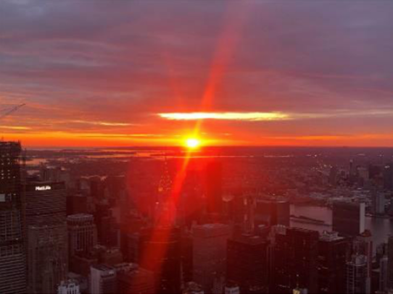

|  |
| --- |
| **Photography –**  **Galleries** |

|  |
| --- |
| **Photography – 102nd Floor** |
|  |
|  |
|  |
|  |

**OTA CHECKLIST**

**Media**

* Ensure all photography is up-to-date and high-res
  + Mix of re-designed interior, view from the observatory and exterior of building
  + Confirm that there are no photos of the Sustainability Exhibit, Dare-to-Dream exhibit, old entrance or former 80th Floor
* Photos highlighting the new lobby and experience
* Remove any photos where the deck looks too crowded or appear to be taken from Top of the Rock
* Include up-to-date Video Assets (when applicable)
* Add photos to Premium Experience Pages (when applicable)
* Photography is [here](https://www.dropbox.com/scl/fo/euyijq40xie10kazu0jsl/ANoWd7c7czrib00uZ_KhBl8?rlkey=7vugxwvqnm9jp8qjdci3o78hj&st=j1s0ta87&dl=0).
* Starbucks Reserve Sunrise Experience imagery is [here](https://www.dropbox.com/scl/fo/wqhln39ob8o1p7h8bdxyx/AK4xAfYorxx2rLI1UycPqOw?rlkey=yvo1kbyp90amhp1ht3dcbmo8l&st=b92lbov8&dl=0).
* Highlight International Lightings and Moments when necessary:
  + India Day: [assets](https://esrtreit.bynder.com/share/2FE0A3AF-9585-482C-87C48F469562F36D/)
  + Brazil Day: [assets](https://esrtreit.bynder.com/share/F3214C6F-0530-4770-AC52EBC59A38BCD2/)
  + Hispanic Heritage Month: [assets](https://esrtreit.bynder.com/share/63BFAC73-9BFE-406E-85ABF3043B2114D9/)
  + Lunar New Year: [assets](https://esrtreit.bynder.com/share/E162075C-8FC2-4AEF-8C6B2E131FD6952A/)
  + Black History Month: [assets](https://esrtreit.bynder.com/share/6453020F-F2F6-4271-A76D2481FED40CEB/)

**Facts and Information**

**Contract Information**

* Ensure key attraction and visitor information is up to date
* Website Listed
* Observatory Entrance Address & Phone Number
* Hours

**Updated Content**

* No mention of old exhibits
* Updated overview & highlights sections. Confirm that images of the 2nd floor museum are prominently featured.
* Website Listed

**Ticket Descriptions**

* Ticket descriptions can be found [HERE](https://www.dropbox.com/scl/fo/ja7ageg0vntsm03fu7wi7/ANShhfl30NrcQar-eliQc3Q?rlkey=awi6443zb2k8h928sidn1cmbu&st=ihnvur24&dl=0).

**Premium Products listed**

* If no – link to website or separate listing

**Ensure Facts are relevant and accurate:**

* Updated FAQs
* View of up to 6 states – New York, New Jersey, Pennsylvania, Connecticut, Massachusetts, and Delaware
* In-Building Dining